Writing an Argumentative Science Essay

These resources have been designed to help teach students how to write a well-structured argumentative science essay (approximately 1,250 words) over the course of a term. They will take part in four interactive in-class activity sessions (intended to last 50 – 60 min each) that each focus on a different, critical theme in writing essays, and which are designed to supplement pre-class homework readings and short activities.

Student essays can be written to address any brief. An example is:

Identify a current controversy in science that interests you. State your opinion, and present the evidence that justifies your position.

The four in-class activity sessions will help students develop their essays (see Table 1).

Table 1: The four topics that will be covered in in-class activity sessions will help students develop their essays over the term. ‘PRE’ classes refer to readings and very short activities that must be completed before they come to the in-class sessions.

Class | Topic
PRE 1 | Good Essay Structure  (thesis and development statements, main body, conclusion)
IN 1

PRE 2 | Using Sources and Avoiding Plagiarism  (primary, secondary and tertiary sources, citing/referencing)
IN 2

PRE 3 | Effective Paragraphing  (paragraph structure, topic sentences, transitions)
IN 3

PRE 4 | Peer Review  (giving and using feedback to improve written work)
IN 4

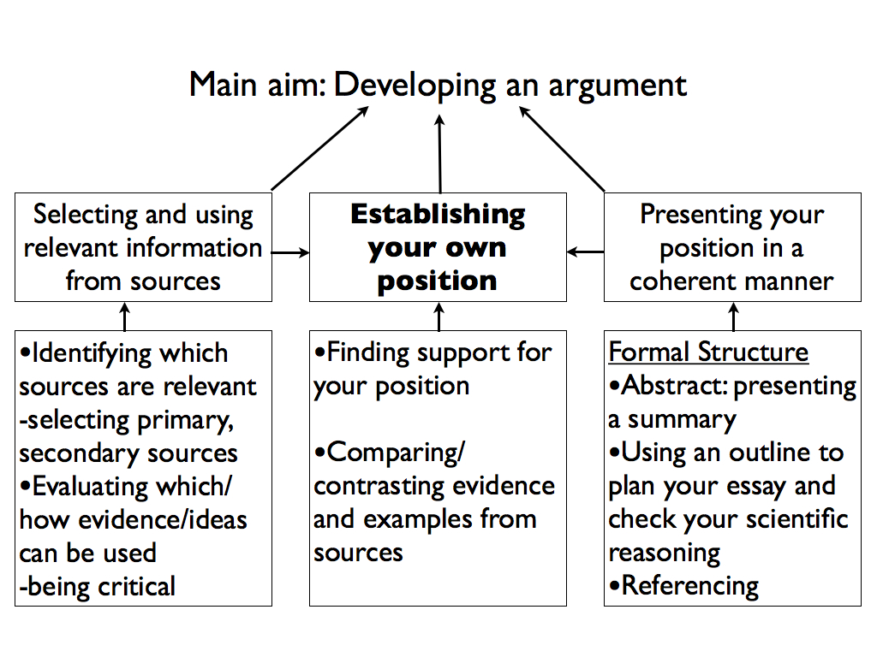
Figure 1. Essay Writing Framework, adapted from: Wingate, U (2012). ‘Argument!’ helping students understand what essay writing is about. Journal for English for Academic Purposes Volume 11: 145-154.

