The Writing Process
Writing is not a finished product; instead, it is a process that involves several different recurring stages. The path you take through these stages will depend on your project and on your writing style, but you may find it helpful to break down the writing process into the stages of prewriting, drafting, revising, and editing.
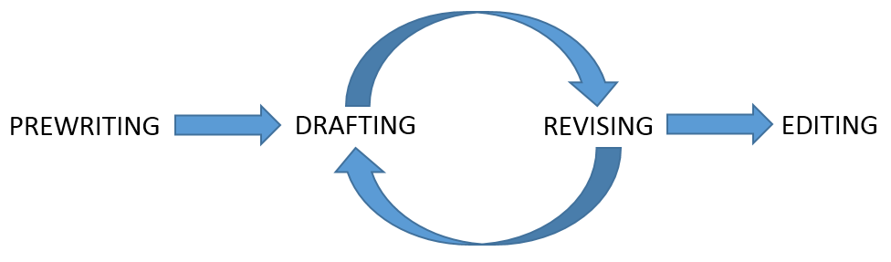
Prewriting
The prewriting stage includes everything you do before writing your first draft. You may want to start with a very detailed read-through of your assignment to make sure you have a clear understanding of the purpose and requirements. Other important parts of prewriting are taking notes, brainstorming, outlining, and researching.
An outline will serve you well throughout the writing process. By outlining how you will organize and present your information, you will keep your writing structured and easy to understand for your reader. See our resource on ‘Creating and Using Writing Outlines’ and our Grammar Squirrel video on ‘Creating Writing Outlines’.
Researching is a very important part of prewriting, and you may find that it is also a component in your drafting and revising stages. As you get further into your writing project, you may realize that you need to explore more sources on a particular topic, or include a source from a different perspective. See our resources on ‘Finding Sources and Literature Searches’, ‘Identifying Different Types of Sources’, Integrating and Citing Sources’, and ‘Science Essay Writing – Essay Structure’.
Questions to ask yourself:
- What do I know about this topic?
- What do I need to know or find out?
- What is my argument or thesis?
- How will I organize and structure my assignment?
Drafting
During the drafting stage, you will actually begin to write! Using the outline you created in your prewriting stage, put your ideas into sentences and paragraphs and begin to explain and support them by logically providing evidence to support different claims that you make along the way. Start to connect your ideas and identify relationships between your points. Make sure you include an introduction with a clear thesis and development statement (see our resource on ‘Science Essay Writing for First Year Undergraduates’ – Essay Structure), as well as body paragraphs that focus on one main point each, and a conclusion that neatly wraps up your work.
Don’t pay attention to spelling or worry about making sure that your punctuation is correct – at this stage, you just want to get your ideas into the document (or “on paper”) in logical order.
Revising
Now that you have something to work with, you can begin to revise your assignment. This stage of the writing process is the key to making your writing effective and coherent. Carefully consider the audience and the purpose of what you are writing. Refine your sentences and paragraphs to make sure your ideas are expressed in the most concise, accurate, and organized way possible.
Once you’ve done some revising, ask a peer or a writing tutor to give you some feedback on your writing assignment. Having someone else read your work can give you valuable insight into whether you have structured your writing appropriately and expressed your thoughts clearly. When you have been working on a piece of writing for some time you are likely to think your logical development makes perfect sense, but it is only when you hear feedback from someone else that you might notice certain gaps in your development, or areas that could confuse other readers.
Another strategy to use is the post-draft outline. Go through your paper and identify the main points from each paragraph; once you have this outline of what you have actually written (vs. the plan you made at the beginning), decide whether your points are in the appropriate order and whether your thesis statement is adequately supported.
Questions to ask yourself:
- What does my reader need to know?
- Which terms need to be defined?
- Is my organization effective?
- Does my thesis statement still reflect the rest of my paper?

Editing (and Proofreading)
Before you hand in your assignment, make sure you do a thorough edit of your own work as the final step to the writing process. Check your grammar, your writing mechanics, your spelling, and your transition words/phrases that link sentences together. Try reading your paper aloud to find awkward sentences or other issues, or reading your paper backwards sentence by sentence. Please see our resources on ‘Grammar and Style’, ‘Organizing’, and ‘Editing, Succinctness, and Dealing with Jargon’.
Questions to ask yourself:
- Is the formatting of my paper in line with the assignment guidelines?
- Have I checked the spelling and grammar myself (beyond spell-check!)?
- Have I included my citations in the correct format?

This resource was adapted from:

https://owl.english.purdue.edu/owl/resource/749/01/
http://www.readwritethink.org/professional-development/strategy-guides/implementing-writing-process-30386.html
http://cmsw.mit.edu/writing-and-communication-center/resources/writers/writing-process/
http://www.hamilton.edu/style/the-writing-process
https://writing.ku.edu/writing-process
http://www.webster.edu/academic-resource-center/writingcenter/writing-tips/process.html
http://collegeunbound.org/2012/09/05/the-writing-process/

